G.S. Lakie Middle School

2017/18 Three Year Education Plan
and
2016/17 Results Report

Vision Statement
Our learners are innovative thinkers who are successful, confident, and caring.

Mission Statement
Lethbridge School District No. 51 is inclusive, forward-thinking, and accountable for engaging students in quality learning experiences that develop strong foundations, innovative minds and responsible citizens
www.lethsd.ab.ca
Lethbridge School District Priority: Supporting Student Achievement.
OUTCOMES:
- Students achieve learning outcomes with strong foundation skills in numeracy and literacy.
- Teachers possess a deep understanding of pedagogy that develops literacy & numeracy.
- Students are lifelong learners possessing the skills and attributes to successfully transition to further education, credentialing, or the world of work.
- FNMI student achievement will meet or exceed provincial standards.
- Teachers are highly skilled in all areas of the Teaching Quality Standard.
- Effective learning and teaching is achieved through collaborative leadership and structures that build capacity to improve within and across schools.

PROVINCIAL GOALS
- Every student is successful
- FNMI achievement gap
- Quality teaching & school leadership
- Engaged and effective governance

Lethbridge School District Priority: Supporting the implementation
of initiatives designed to develop innovative thinkers
OUTCOMES:
- Students demonstrate the attributes of innovation, creativity and critical thinking.
- Learning is process-based supported by instructional practices that engage students in creative and critical thinking
- All learners effectively use technology as creative and critical thinkers
- A breadth of high quality programs within and outside the classroom foster innovative thinking.
- The school demonstrates collaboration and engagement.

Performance Measures
- Students are taught attitudes and behaviours that will make them successful at work when they finish school
- Opportunity for students to receive a broad program of studies,
- Teacher, parent and student satisfaction with the overall quality of basic education, school improvement and decision making

Strategies
- Continue to implement mandatory embedded technology tutorials and digital citizenship for all grade 6, 7 and 8 students.
- Provide teachers opportunities to explore new digital tools and applications, such as Office 365, Windows 10.
- Introduce a “tech-tip” corner at each staff meeting, during which new applications are explored with staff.
- Provide and encourage appropriate student device opportunities in the classroom setting.
- Invite and encourage staff sharing of instructional practices that engage students in innovative learning, critical thinking and creativity in order to build a common understanding.
- Continue to offer extensive option programming which fosters innovative, creative and critical thinking.
- Continue to implement and grow a new Career and Technology Foundations model that supports and focuses on inquiry and process-based learning.
- Offer a breadth of extra-curricular activities that foster innovative thinking, such as Robotics club, tech minions, fine arts tech crew.
- Continue to further develop a Learning Commons model which will encourage student collaboration, innovation and engagement.

Strategies
- Explore the new draft Teacher Quality Standards with teaching staff and provide professional learning time during staff meetings and professional learning days to explore the standards in depth.
- Offer professional learning to help staff build foundational knowledge of First Nations, Metis and Inuit history and culture.
- Continue the growth and development an FNMI Youth Mentors Program in partnership with the University of Lethbridge.
- Become more intentional in whole-school celebration of Indigenous culture; for example, hosting Orange Shirt Day and Rock Your Mocs, and raising a Blackfoot flag at Lakie.
- Schedule a pre and post literacy assessment of identified students with results being analyzed to determine appropriate areas of need for intervention.
- Continue offering literacy intervention at the grade 6, 7 and 8 level during scheduled time as provided by the timetable. Students identified as requiring support will work in small groups with Language Arts specialists, using a variety of resources for intervention, including, but not limited to, Fountas and Pinnell.
- Begin to offer numeracy intervention for students identified as requiring support.

Performance Measures
- Students achieve student learning outcomes and demonstrate proficiency in literacy and numeracy.
- Teachers effectively engage students and instructional practice reflects the Teaching Quality Standard.
- Accountability pillar outcomes relative to achievement of all students and growth in FNMI outcomes

PROVINCIAL GOALS
- Every student is successful
- FNMI achievement gap
- Quality teaching & school leadership
- Engaged and effective governance

Lethbridge School District Priority: Supporting Student Diversity
OUTCOMES:
- Schools are welcoming, caring, respectful and safe learning environments.
- Schools are inclusive learning environments.
- Students with diverse learning and social needs are supported.
- Schools are learning environments that promote healthy lifestyles.

School Priority:

OUTCOMES:
- Review and reflect on the culture of Lakie in preparation for embracing a restructured middle school community.

Strategies
- Continue to participate in Lethbridge School District 51’s middle school visioning committee.
- Introduce the new mission and vision statement for middle schools in Lethbridge School District.
- Continue to support and be involved in a Lethbridge School District Middle School Collaborative Learning Community.
  - Examine current research on middle school philosophy / best practice.
  - Send a team to the Association of Middle Level Educators conference in November 2017.
  - Extend collaborative community opportunities among all middle school sites.
- Continue to review the athletics model and how it corresponds to the middle school philosophy.
- Explore the possibility of continuing to work with the west-side learning community, focussing on developing educational skill sets (through release time or collaborative communities).
- Discuss and embrace the upcoming changes within Lakie and explore the opportunities created with the change.

Performance Measures
- Programming of G.S. Lakie Middle School will be in place.
- Implementing the elements of Middle School redesign, an educational framework will be set to ensure future academics, athletics and fine arts programs are addressed.

Strategies
- Continue to infuse the FISH! Philosophy in the Lakie community.
- Continue to provide students with citizenship/volunteerism opportunities (Me to We, District Student Advisory Council, We Scare Hunger, VocaliD).
- Continue partnership with Big Brothers Big Sisters to support adolescents with the Game On program and Go Girls mentorship program.
- Continue to offer individualized, targeted and universal supports to students through a cohesive counselling team.
- Continue to support a G.S.A (Gay-Straight Student Alliance) Positive Spaces group for the Lakie community.
- Explore the use of advisor time in an effort to promote caring, respectful and responsible citizens.
- Introduce a resiliency education program at Grade 6 (GRIT).
- Continue to utilize Learning Support teachers to support students and teachers within their classes with differentiated instruction for all learners.
- Promote whole-staff collaboration to best support the learning and emotional needs of ELL students.

Performance Measures
- Improvement on the continuum of the Indicators of Inclusive Schools.
- Students model the characteristics of active citizenship.
- Students are safe at school, learning about the importance of caring and respect for others and are treated fairly at school.
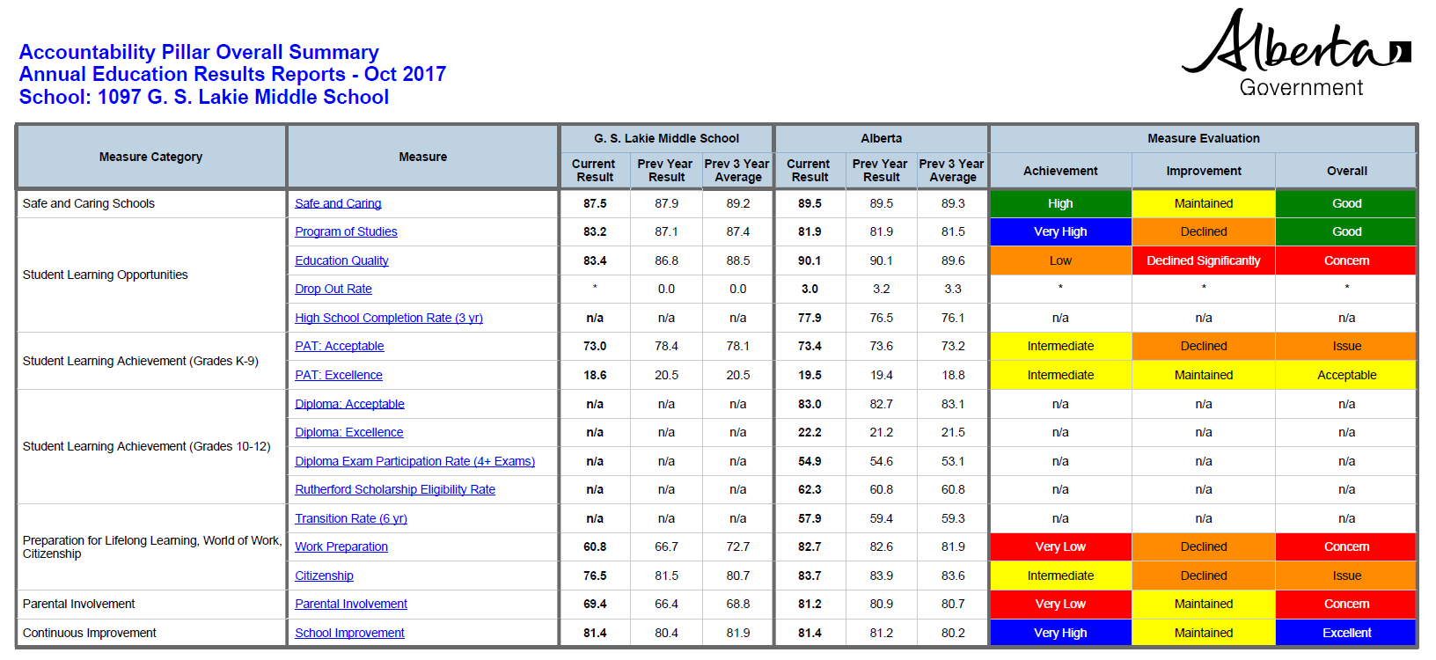
Highlights

Accountability Pillar Results

- On the Accountability Pillar, overall satisfaction with the variety of programming being offered was very high among parents, teachers and students.
- Results on the School Improvement section of the Accountability Pillar were very high from parents, teachers and students; our proudest compliment is that almost 90% of our students would recommend Lakie to a friend.
- The facility partnership with New West Theatre and fine arts community in Lethbridge.
- G.S. Lakie has given out fine arts scholarships to students in Southern Alberta the past 7 years.
- Successful fundraising contributing to the future development of a multisport park at G.S. Lakie to be completed the fall of 2018.
- Provide opportunities for all students, regardless of their ability, to participate in co-curricular activities.
- Continued partnership with the University of Lethbridge for a First Nations, Metis and Inuit mentorship program.
- A strong connection among staff, and a strong connection with students, regardless of the size of Lakie.
- Events that build community (FISH Fridays, Wednesday “Hump Day” breakfast, collaborative times, retreat).

- On the Accountability Pillar, parents were not as satisfied as teachers with the overall quality of education at Lakie. This will require ongoing dialogue with parents to identify specific areas of concern.
- Parent satisfaction was low with the attitudes and behaviours being taught their children to prepare for the workforce.
- We would like to address the small sample size of parent respondents to the survey, as only 30 people participated last year.
- Staff perspective differs from student and parent perspective with regards to citizenship.
- In terms of parental involvement, parents generally expressed satisfaction with input into their child’s education, but dissatisfaction with input about decisions regarding the school itself.
- PAT results for the written portion of Math and Language Arts exams were both lower than provincial averages.
- Providing appropriate curriculum and physical space adjustments due to student enrollment increases.
- Finding balance between a traditional library and a Learning Commons model.
- Ensuring the Lakie community continues to have the feel of a family regardless of population increases and the upcoming change.
- Engagement of FNMI students in the overall school community.

Challenges to Address

Challenges to Address

- Closing the achievement gap between students achieving Standard of Excellence on the PAT and those falling below Acceptable Standard.
- Providing physical space adjustments due to student enrollment increases.
- Finding balance between a traditional library and a Learning Commons model.
- Moving towards more whole-staff collaboration to meet the needs of ELL learners.
- Addressing student needs for support in the areas of stress, anxiety and depression as indicated from the Tell Them From Me survey (resiliency).
- Ensuring the Lakie community continues to have the feel of a family regardless of population increases and the upcoming change.
- Provide School Council with new strategies to encourage and improve meaningful parent involvement.
- Engagement of FNMI students in the overall school community.

